# I. Install Visual Studio

Installation link: <https://visualstudio.microsoft.com/>

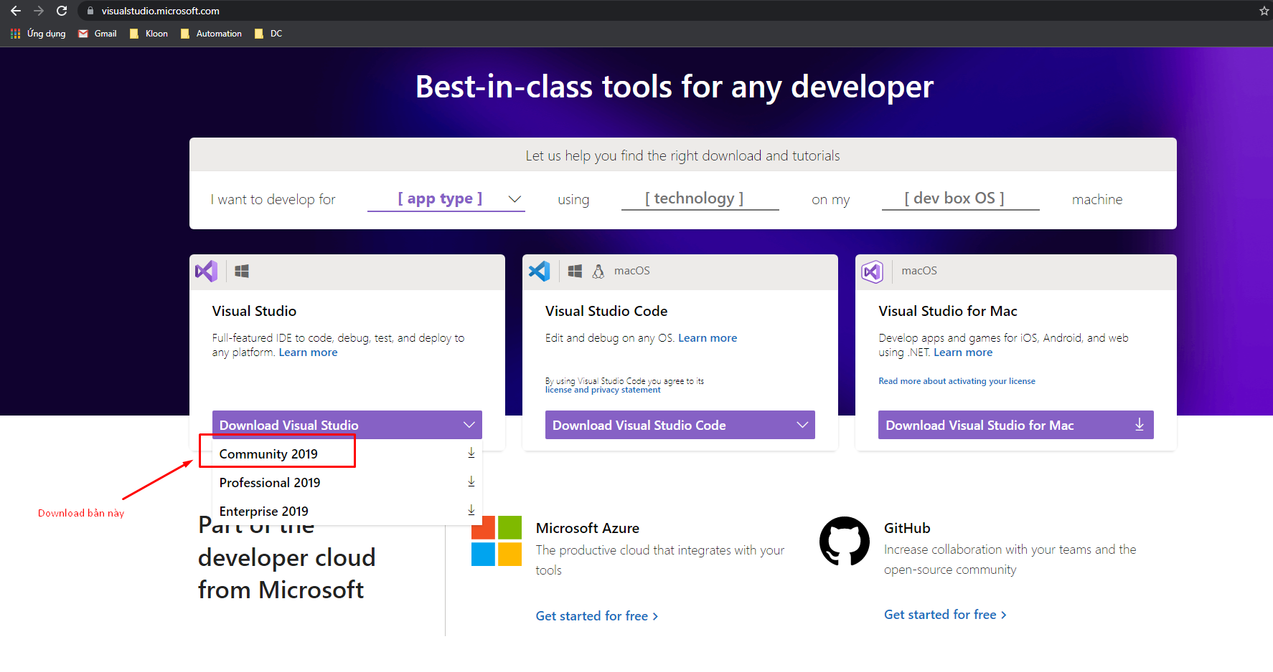

* Download Visual studio and click install
* Click on the box as shown in the picture and click install

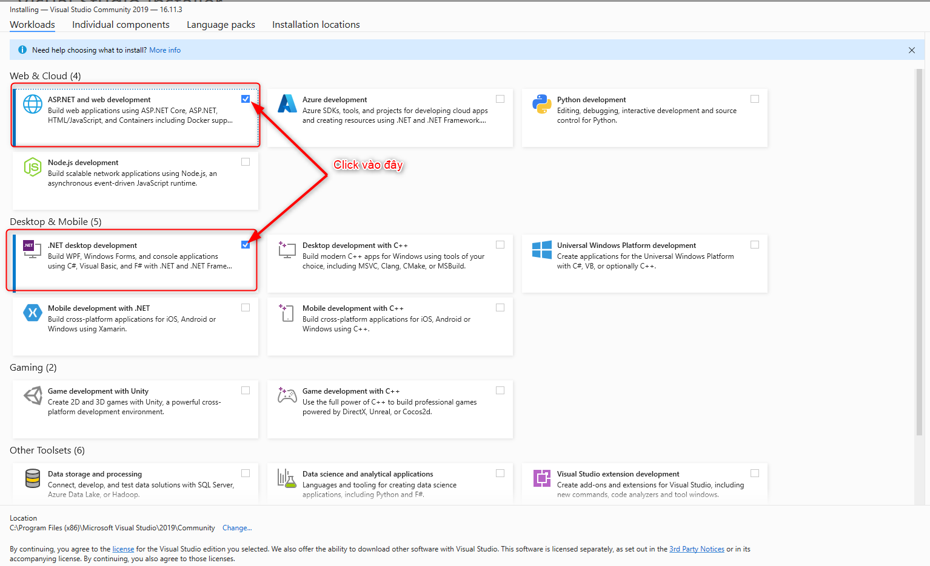

# **II. Run solution**

1. **Open solution**

* Open folder
* Select solution file

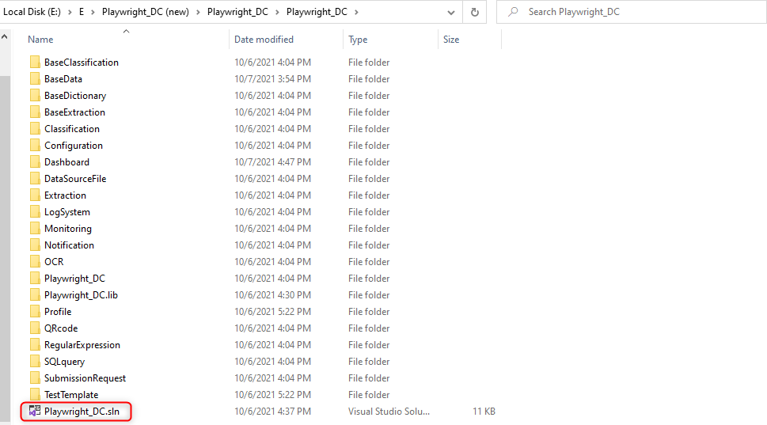

* After clicking, the screen will display as follows

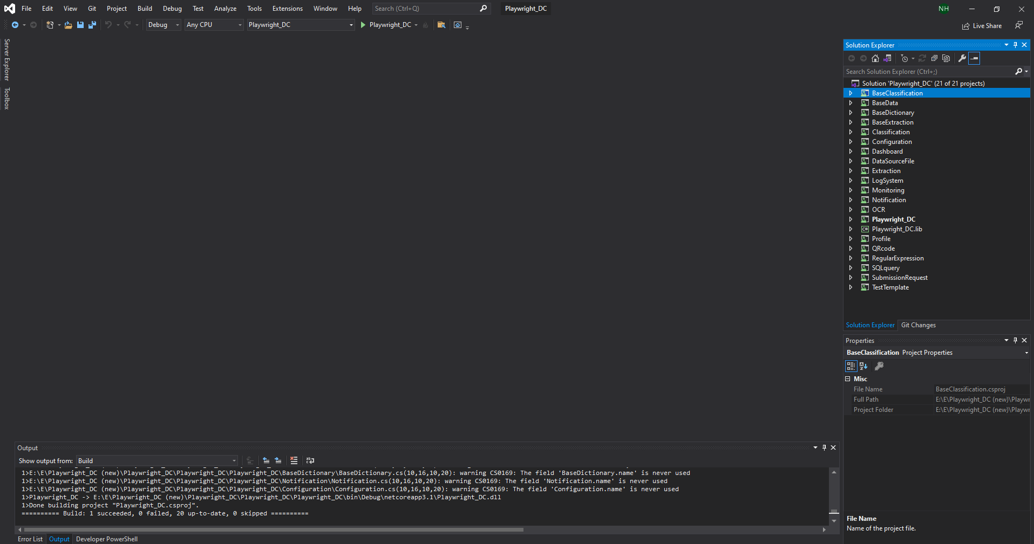

1. **Run test a Project**

* Click “Test”

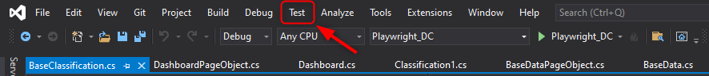

* Select “Test Explorer”

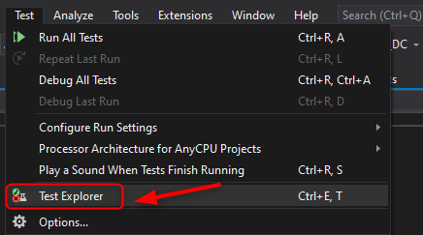

* Show Test Explorer popup

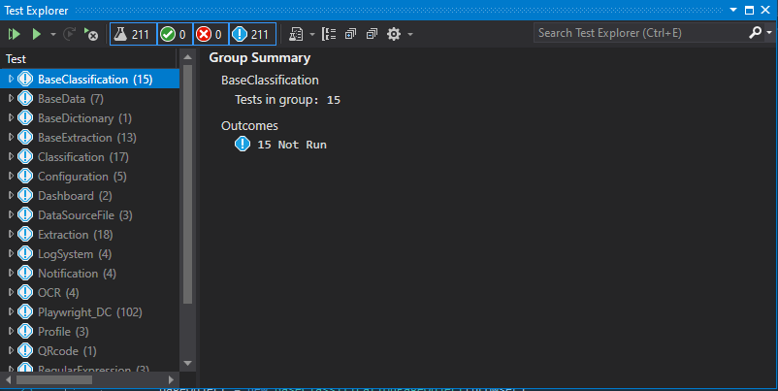

* Select a Project, right-click and select Run

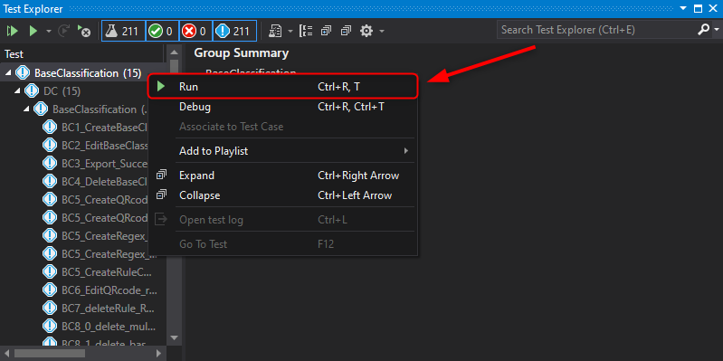

* Show Pass/Fail results

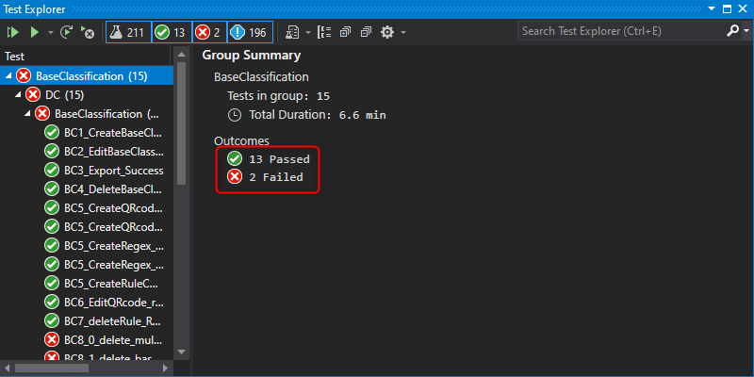

1. **Run test Solution**

* Click “Test” -> Select “Run All Tests”

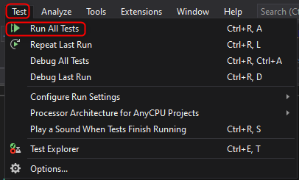

* Show Pass/Fail results of each Project

